**Bagal Komal Ramesh**

**Program No 1 - Addition of Two numbers.**

#include <stdio.h>

int main()

{

int a,b,c;

printf("enter 2 numbers");

scanf("%d %d",&a,&b);

c=a+b;

printf("Addition =%d",c);

return 0;

}

Output-

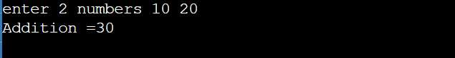

**Program No 2 - Subtraction of three numbers.**

#include <stdio.h>

int main()

{

int a,b,c,d;

printf("enter numbers");

scanf("%d %d %d",&a,&b,&c);

c=a-b-c;

printf("subtraction=%d",c);

return 0;

}

Output-

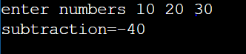

**Program No 3 - Multiplication of Four numbers.**

#include <stdio.h>

int main()

{

int a,b,c,d,e;

printf("enter 4 numbers");

scanf("%d %d %d %d",&a,&b,&c,&d);

e=a*b*c*d;

printf("Multiplication=%d",e);

return 0;

}

Output-

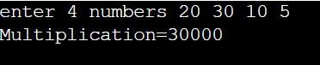

**Program No 4 - Addition of Five numbers**.

#include <stdio.h>

int main()

{

int a,b,c,d,e,f;

printf("enter 5 numbers");

scanf("%d %d %d %d %d",&a,&b,&c,&d,&e);

f=a+b+c+d+e;

printf("addition=%d",f);

return 0;

}

Output-



**Program No 5 - Division of Two numbers**.

#include <stdio.h>

int main()

{

int a,b,c;

printf("enter 2 numbers");

scanf("%d %d",&a,&b);

c=a/b;

printf("Division=%d",c);

return 0;

}

Output-

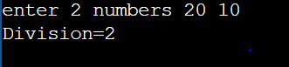

**Program No 6 - Area of Circle.**

#include <stdio.h>

int main()

{

float A,r;

printf("enter radius");

scanf("%f",&r);

A=3.14*r*r;

printf("Area=%f",A);

return 0;

}

Output-

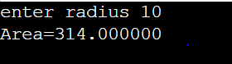

**Program No 7 - Area of rectangle.**

#include <stdio.h>

int main()

{

float length,breadth,Area;

float area;

printf("enter length of rectangle");

scanf("%f",&length);

printf("enter breadth of rectangle");

scanf("%f",&breadth);

Area=length*breadth;

printf("Area of Rectangle=%f",Area);

return 0;

}

Output-

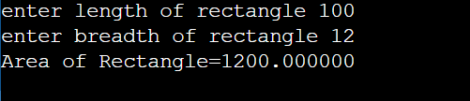

**Program No 8 - Area of Circle.**

#include <stdio.h>

int main()

{

float A,r;

printf("enter radius");

scanf("%f",&r);

A=3.14*r*r;

printf("Area=%f",A);

return 0;

}

Output-

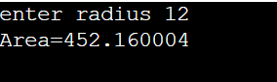

# Program No 9 - Kinetic Energy .

#include <stdio.h>

int main()

{

float mass,velocity,ke;

printf("Enter the mass of the object: ");

scanf("%f", &mass);

printf("Enter the velocity of the object: ");

scanf("%f", &velocity);

ke=0.5*mass*velocity*velocity;

printf("\n kinetic energy is %f",ke);

return 0;

}

Output-

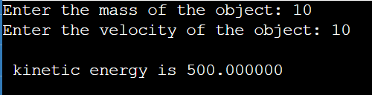

# Program No 10 - Potential Energy.

#include <stdio.h>

int main()

{

float m,g=9.8,h,pe;

printf("Enter the mass : ");

scanf("%f", &m);

printf("Enter the height:");

scanf("%f", &h);

pe=m*g*h;

printf("\n potential energy is %f",pe);

return 0;

}

Output-

